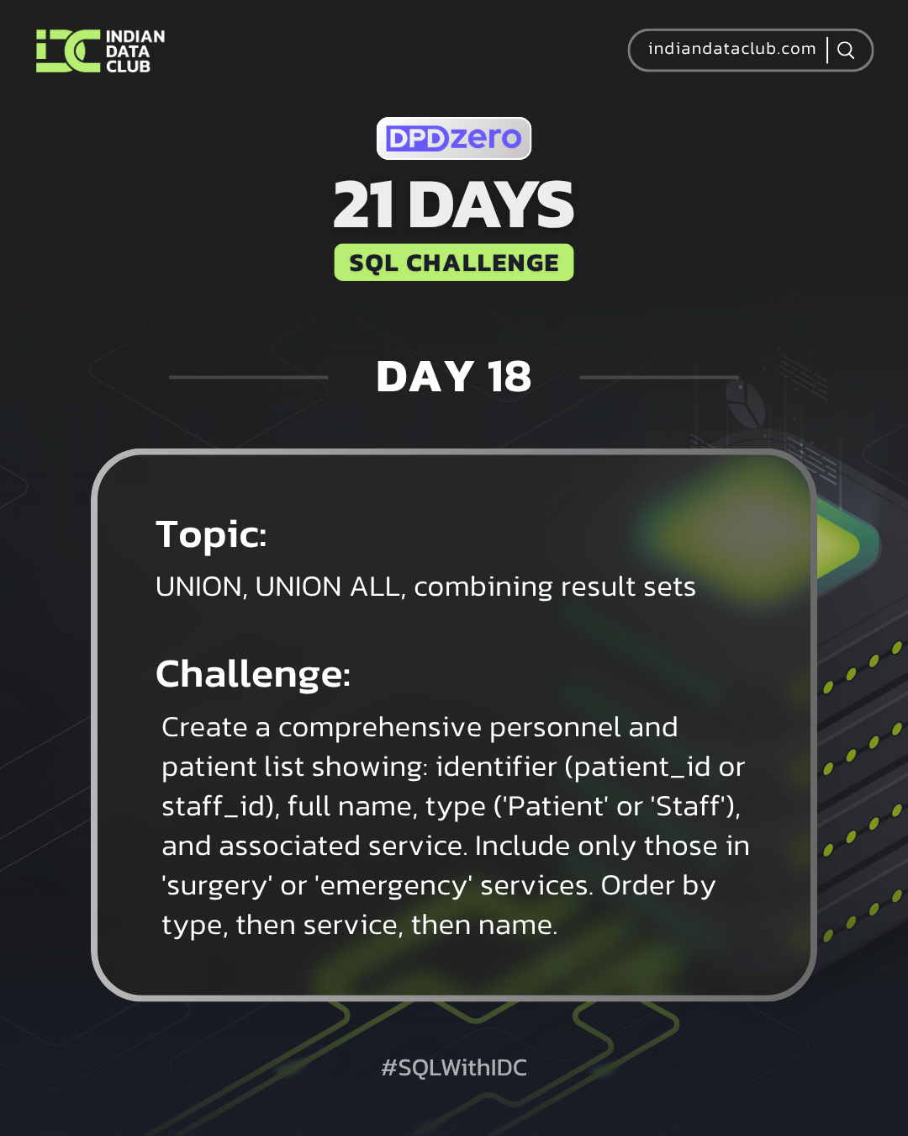

Day-18 SQL Challenge
Day-18 Challenge:
Create a comprehensive personnel and patient list showing: identifier (patient_id or staff_id), full name, type ('Patient' or 'Staff'), and associated service. Include only those in 'surgery' or 'emergency' services. Order by type, then service, then name.
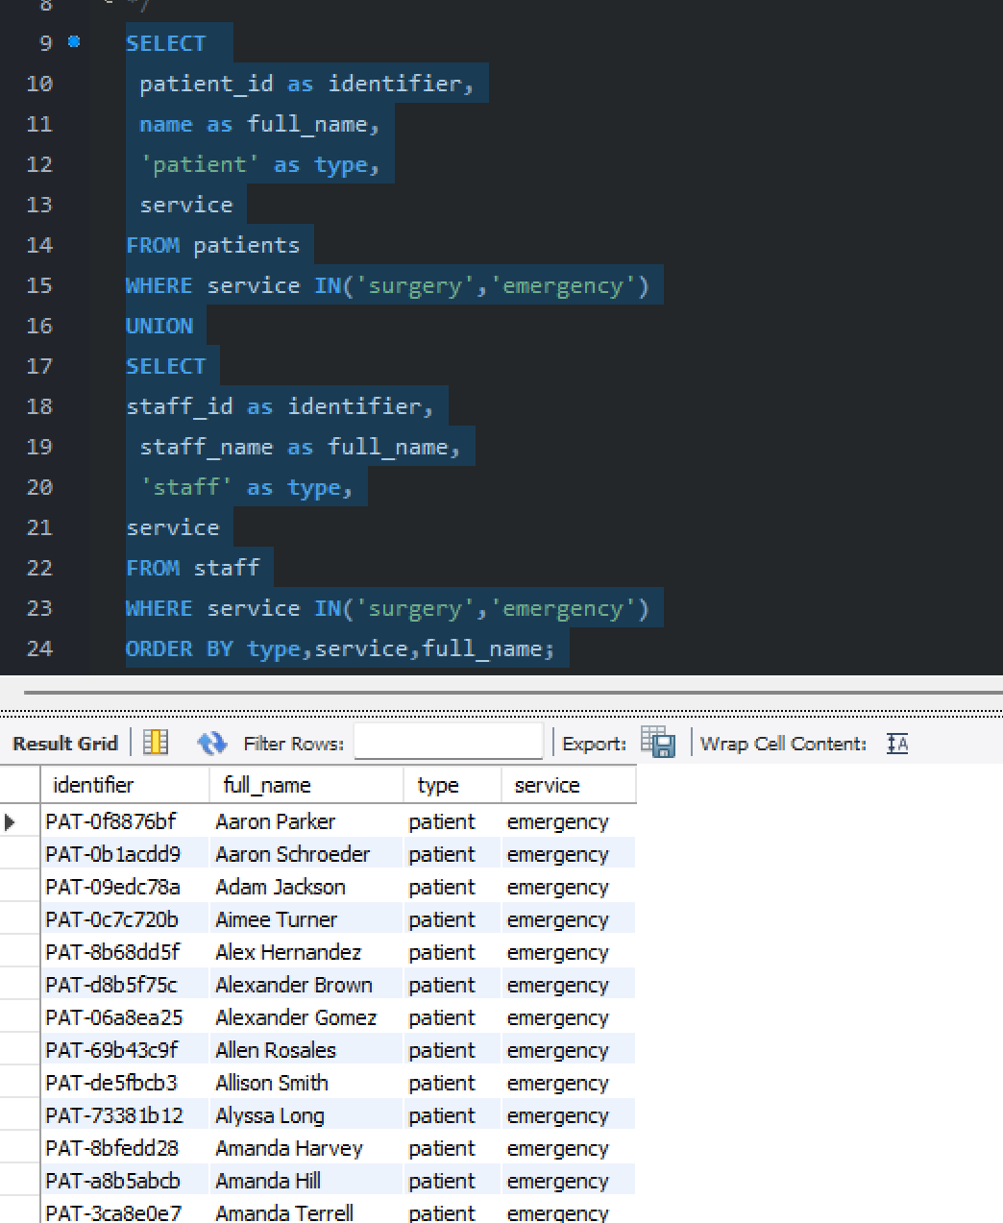

Practise Questions:
1. Combine patient names and staff names into a single list.
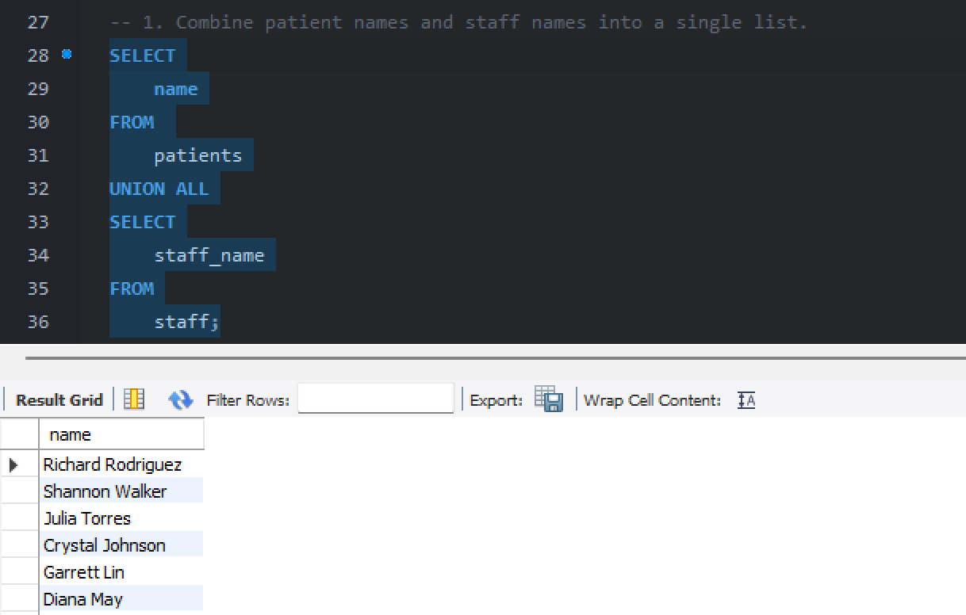
2. Create a union of high satisfaction patients (>90) and low satisfaction patients (<50).
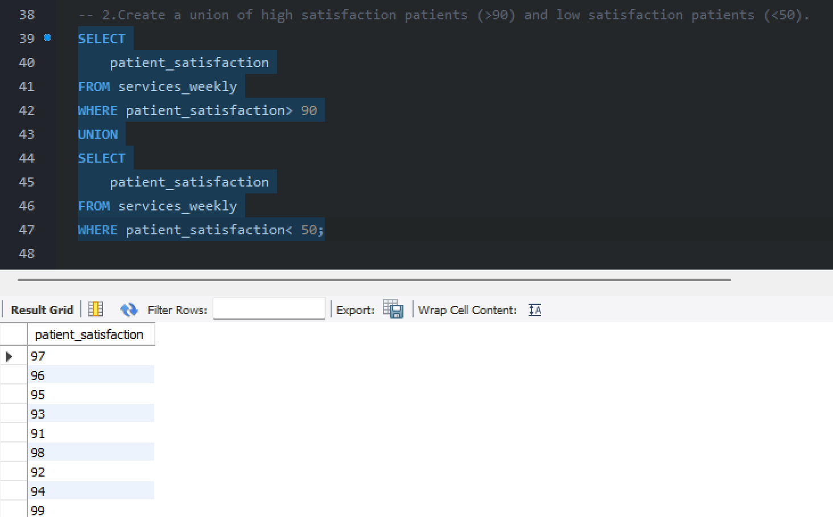

3. List all unique names from both patients and staff tables.
